# 

### Machine Learning for Time Series Prediction, Comparative analysis

Olu Salami

A Thesis in the Field of Computational Finance

for the Degree of Master of Science in Computational Finance

University of Greenwich

January 2019

Copyright 2018 [David Salami]

Abstract

Autonomous and Automated decision making in the area of trading securities

Keywords: Machine learning; Convolutional Neural Networks; Recurrent Neural Networks; LSTM; Reinforcement learning; Machine Learning; Forex; Algorithmic Trading; Portfolio Management; Quantitative Finance; Q-learning; Markov Decision Process;

### Dedication (optional)

To delete this or any other unwanted section, select it in its entirety, including the title and the Section Break, and press Backspace or Delete.

### Acknowledgments (optional)

To delete this or any other unwanted section, select it in its entirety, including the title and the Section Break, and press Backspace or Delete. To see the Section Break, show formatting symbols by clicking the ¶ button in the Paragraph section

### Table of Contents

Machine Learning for Time Series Prediction, Comparative analysis 1

Chapter 1 1

Dedication (optional) 5

Acknowledgments (optional) 6

Table of Contents 7

List of Tables (optional) 11

List of Figures (optional) 12

2. Chapter I. Introduction 13

Introduction 14

Problem Background 14

Problem Statement 14

Purpose of Study 14

Project Objectives 14

Scope of Study 14

The Significant of Study 14

Organization of Report 14

3. Chapter II. Literature Review 15

Introduction 15

Phishing 15

Existing Anti-Phishing Approaches 15

Summary 15

4. Chapter III. Research Methodology 16

Introduction 16

Stock prediction 16

Efficient market theory 17

Predictability of stock 17

Time series forecasting 17

Arima 18

Autoregressive Integrated Moving Average Model 18

Var 24

Vector Auto Regression 24

Machine Learning 28

Neural Network 29

CNN 29

RNN 29

GRU 29

Attention based networks 29

LSTM 29

Inference from review 30

Inference from research 30

Summary 50

5. Chapter IV. Classical Methods 51

Exploratory Data Analysis 51

Auto Regressive Integrated Moving Average 55

6. Chapter IV. LSTM 56

Mathematical Formulation 56

Experiment 56

Dataset Division 56

Building The Model 56

Training Model 56

Validation Technique 56

Tuning The Model 56

Summary 56

7. Chapter V. Comparative Analysis 57

Experimental Data 57

Training and Validation Dataset 57

Building the model 58

Running the Forecast 59

Epoch size 61

Model training Vs Validation Loss 64

Batch size 66

Number of neurons 67

Pertubing the Model 69

Summary 70

8. Conclusion. 71

Concluding Remarks 71

Key Points 72

Recommendations for Future Research 72

Dropout, Optimization Algorithm, Loss Function. 73

LSTM in deep reinforcement learning for time series prediction 73

9. [References] 74

Bibliography 74

### List of Tables (optional)

Table 1. Table Title. 2

Table 2. Table Title 2

### List of Figures (optional)

Figure 1. Figure Title. 2

Figure 2. Figure Title 2

## Chapter I. Introduction

#### Brief History of Gold

Gold, measured out, became money. Gold along with its many properties, first discovered as shiny yellow pieces, has always been desired by every culture for it beauty, lustre. Gold was money in many ancient civilisations, its portability, permanence, divisibility and desirability made it an attractive medium of exchange. The idea of gold as a medium of exchange preceded money as we know it. Classic philosophers such as Plato wrote about gold. Homer in the "Iliad" and "Odyssey," refers of gold as the glory of the immortals and a sign of wealth among humans. There is also reference to gold in the bible, Genesis 2:10-12, we learn of the river Pison out of Eden, and "the land of Havilah, where there is gold: and the gold of that land is good?”.

Gold as a commodity, has been an haven for investors in time of high volatility and market uncertainty, it’s role in the international monetary system came to an end in the early 1970’s . It experienced a sudden but short-lived price fluctuation in the early and late 70’s. Gold purchases is a mixed bag, e.g. industrial, personal use and investment. fluctuation in gold prices is largely owing to gold purchase as a store of value, i.e. investments.

“In the recent past, yet the amounts have been significant in relation to the supply of new gold. From 1977 to 1979, net official sales (largely by the U.S. and the IMF) represented 1175 metric tons, compared to 3892 metric tons of new production. From 1980 to 1982, official purchases averaged nearly 200 metric tons per year. But, except for some bi-lateral transactions within the Soviet Bloc and transactions by smaller nations, there have been no gold transactions among Western banks since before the suspension of convertibility in 1971. What is even more important is that public officials have developed a great reluctance to gamble in the gold market and risk making conspicuous mistakes. Thus, it is unlikely that changes in official stocks will play an important role in gold price movements.” (Baker & van Tassel, 1985)

There are two ways to add a new chapter. First, you can simply type the name of

**Research question,**

1. How well does LSTM perform with relatively limited dataset ( illiquid asset ) in a machine learning context. The commodity Gold was selected for its low volatility.

2) In contract too existing forecasting model, how well does LSTM perform. My hypothesis is that LSTM will outperform existing (non ML) models

The question of using limited dataset is significant as this is sometimes considered ineffective machine learning domain. Where experiments are often performed with millions of data records

### Introduction

### Problem Background

### Problem Statement

### Purpose of Study

### Project Objectives

### Scope of Study

Background

### The Significant of Study

### Organization of Report

.

## Chapter II. Literature Review

### Introduction

### Phishing

### Existing Anti-Phishing Approaches

### Summary

## Chapter III. Research Methodology

### Stock prediction

Asset price prediction is an oft researched topic in finance. The body of work dedicated to predicting asset price movement is extensive. There has been limited success in application of new predictive methods for stock price movements. The challenges of predicting asset price movement lies in the underlying convolution of simulating market dynamics. The two fundamental and opposing schools of thought when it comes to analyzing financial markets are the technical and fundamental analyst. Technical analysts focus on directly observable data, e.g price movement of a security and repurpose the data to predict future price movements. Fundamental analysts on the other hand take a wider and longer time horizon of the company or commodity, such as economic and financial factors that may drives the business, e.g demand for a product. The task of forecasting future prices requires deeper understanding of the stock markets, economic and market data, sentiment or even the weather. the prospective model must consider contextual and analytic data in order to simulate and model uncertainties in the real world.

### Efficient Market Hypothesis

Developed by Eugen Fama, the Efficient Market Hypothesis implies that stock prices reflect all available and relevant information, so one can not outperform the market or consistently beat the market. This implies it’s theoretically not possible to purchase stocks undervalued or sell stocks overpriced. There are three forms of efficient market hypothesis. In its weak-form, there's no correlation between successive rates, which means that excess returns can't always be done through the analysis of past price movements. This type of analysis is known as graph evaluation, since it's founded on the analysis of past price patterns without any respect to some additional background info. In its semi-strong form, the theory dismisses the viability of the fundamental and technical analysis. It builds on the assumptions of the weak-form by supposing that prices adjust rapidly to new publicly accessible data, consequently invalidating the predictive value of fundamental analysis with respect to future price moves. In it’s strong-form, the present market price is the best accessible predictor of a fair price, with regard to all relevant information, public and private. The implication here is that one cannot consistently beat the market or make excess returns.

Can the market be tamed it predicted , what been don on this for ref

### Time series forecasting

Time series models are very important in business applications, they have been used over the last 30 years to great success. Lots of business rely on time series model to project earnings, capital expenditure and to prepare budgets for the next economic period. There are various methods for forecasting values of a time series from past observations. Given a time series of spaced observations Yt, t = 1,2, ..., n on a quantity Y, we require to forecast Yf+h, h= 1, 2, 3, There are a good number of techniques, with varying levels of complexity, that can deliver reasonable accurate results.

**Stationarity**

Stationary refers to time series where properties such as the mean, variance and autocorrelation remain unchanged over time. Hence, a time series is said to be non-stationary where its statistical properties changes over time.

**Dickey Fuller test**

**Random walk**

A type of time series model where the current value is equal to the previous value with a random step, it can be described as a [process](https://en.wikipedia.org/wiki/Random_process" \o "Random process) that describes a path that consists of a succession of arbitrary steps in a mathematical space

**Autocorrelation**

[Autocorrelation](http://en.wikipedia.org/wiki/Autocorrelation) is a measure of the internal correlation within a time series. It is a way of measuring and explaining internal association between observations in a time series.

**Residuals**

The difference between the observed values and forecasted values, at time t. If yt is the observed value and ŷt is the forecasted value, are known as residuals residual error series

(*xt*), *xt=yt−ŷt*

This research will be limited to univariate time, although there are a few cases where good success has been achieved on multivariate time series (Zachary et al, 2015) see mendley to add citation

Arima

Describe, define, uses, maths, current work, your view

3.1. Preamble Early attempts to study time series, particularly in the 19th century, were generally characterized by the idea of a deterministic world. It was the major contribution of Yule (1927) which launched the notion of stochasticity in time series by postulating that every time series can be regarded as the realization of a stochastic process. Based on this simple idea, a number of time series methods have been developed since then. Workers such as Slutsky, Walker, Yaglom, and Yule first formulated the concept of autoregressive (AR) and moving average (MA) models. Wold’s decomposition theorem led to the formulation and solution of the linear forecasting problem of Kolmogorov (1941). Since then, a considerable body of literature has appeared in the area of time series, dealing with parameter estimation, identification, model checking, and forecasting; see, e.g., Newbold (1983) for an early survey. The publication Time Series Analysis: Forecasting and Control by Box and Jenkins (1970)3 integrated the existing knowledge. Moreover, these authors developed a coherent, versatile three-stage iterative

cycle for time series identification, estimation, and verification (rightly known as the Box–Jenkins approach). The book has had an enormous impact on the theory and practice of modern time series analysis and forecasting. With the advent of the computer, it popularized the use of autoregressive integrated moving average (ARIMA) models and their extensions in many areas of science. Indeed, forecasting discrete time series processes through univariate ARIMA models, transfer function (dynamic regression) models, and multivariate (vector) ARIMA models has generated quite a few IJF papers. Often these studies were of an empirical nature, using one or more benchmark methods/models as a comparison. Without pretending to be complete, Table 1 gives a list of these studies. Naturally, some of these studies are more successful than others. In all cases, the forecasting experiences reported are valuable. They have also been the key to new developments, which may be summarized as follows. 3.2. Univariate The success of the Box–Jenkins methodology is founded on the fact that the various models can, between them, mimic the behaviour of diverse types of series—and do so adequately without usually requiring very many parameters to be estimated in the final choice of the model. However, in the midsixties, the selection of a model was very much a matter of the researcher’s judgment; there was no algorithm to specify a model uniquely. Since then, many techniques and methods have been suggested to add mathematical rigour to the search process of an ARMA model, including Akaike’s information criterion (AIC), Akaike’s final prediction error (FPE), and the Bayes information criterion (BIC). Often these criteria come down to minimizing (in-sample) onestep-ahead forecast errors, with a penalty term for overfitting. FPE has also been generalized for multistep-ahead forecasting (see, e.g., Bhansali, 1996, 1999), but this generalization has not been utilized by applied workers. This also seems to be the case with criteria based on cross-validation and splitsample validation (see, e.g., West, 1996) principles, making use of genuine out-of-sample forecast errors; see Pen˜a and Sa´nchez (2005) for a related approach worth considering. There are a number of methods (cf. Box et al., 1994) for estimating the parameters of an ARMA model. Although these methods are equivalent asymptotically, in the sense that estimates tend to the same normal distribution, there are large differences in finite sample properties. In a comparative study of software packages, Newbold, Agiakloglou, and Miller (1994) showed that this difference can be quite substantial and, as a consequence, may influence forecasts. They recommended the use of full maximum likelihood. The effect of parameter estimation errors on the probability limits of the forecasts was also noticed by Zellner (1971). He used a Bayesian analysis and derived the predictive distribution of future observations by treating the parameters in the ARMA model as random variables. More recently, Kim (2003) considered parameter estimation and forecasting of AR models in small samples. He found that (bootstrap) bias-corrected parameter estimators produce more accurate forecasts than the least squares estimator. Landsman and Damodaran (1989) presented evidence that the James-Stein ARIMA parameter estimator improves forecast accuracy relative to other methods, under an MSE loss criterion. If a time series is known to follow a univariate ARIMA model, forecasts using disaggregated observations are, in terms of MSE, at least as good as forecasts using aggregated observations. However, in practical applications, there are other factors to be considered, such as missing values in disaggregated series. Both Ledolter (1989) and Hotta (1993) analyzed the effect of an additive outlier on the forecast intervals when the ARIMA model parameters are estimated. When the model is stationary, Hotta and Cardoso Neto (1993) showed that the loss of efficiency using aggregated data is not large, even if the model is not known. Thus, prediction could be done by either disaggregated or aggregated models. The problem of incorporating external (prior) information in the univariate ARIMA forecasts has been considered by Cholette (1982), Guerrero (1991), and de Alba (1993). As an alternative to the univariate ARIMA methodology, Parzen (1982) proposed the ARARMA methodology. The key idea is that a time series is transformed from a long-memory AR filter to a shortmemory filter, thus avoiding the bharsherQ differencing operator. In addition, a different approach to the dconventionalT Box–Jenkins identification step is used. In the M-competition (Makridakis et al., 1982), the ARARMA models achieved the lowest MAPE for longer forecast horizons. Hence, it is surprising to find that, apart from the paper by Meade and Smith (1985), the ARARMA methodology has not really taken off in applied work. Its ultimate value may perhaps be better judged by assessing the study by Meade (2000) who compared the forecasting performance of an automated and non-automated ARARMA method. Automatic univariate ARIMA modelling has been shown to produce one-step-ahead forecasts as accurate as those produced by competent modellers (Hill & Fildes, 1984; Libert, 1984; Poulos, Kvanli, & Pavur, 1987; Texter & Ord, 1989). Several software vendors have implemented automated time series forecasting methods (including multivariate methods); see, e.g., Geriner and Ord (1991), Tashman and Leach (1991), and Tashman (2000). Often these methods act as black boxes. The technology of expert systems (Me´lard & Pasteels, 2000) can be used to avoid this problem. Some guidelines on the choice of an automatic forecasting method are provided by Chatfield (1988). Rather than adopting a single AR model for all forecast horizons, Kang (2003) empirically investigated the case of using a multi-step-ahead forecasting AR model selected separately for each horizon. The forecasting performance of the multi-step-ahead procedure appears to depend on, among other things,

#### Var

Describe, define, uses, maths, current work, your view

### Vector Auto Regression

A VAR model is a generalisation of the univariate autoregressive model for forecasting a vector of time series. It comprises one equation per variable in the system. The right hand side of each equation includes a constant and lags of all of the variables in the system. To keep it simple, we will consider a two variable VAR with one lag. We write a 2-dimensional VAR(1) as Eq1.1

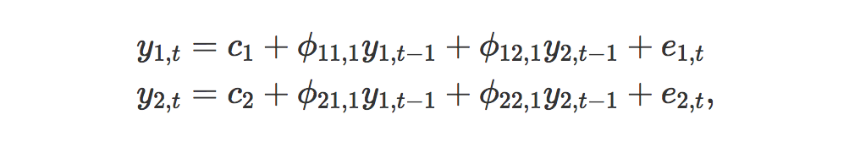

where e1,t and e2,t are white noise processes that may be contemporaneously correlated. The coefficient ϕii,ℓ captures the influence of the ℓth lag of variable yi on itself, while the coefficient ϕij,ℓ captures the influence of the ℓth lag of variable yj on yi.

If the series are stationary, we forecast them by fitting a VAR to the data directly (known as a “VAR in levels”). If the series are non-stationary, we take differences of the data in order to make them stationary, then fit a VAR model (known as a “VAR in differences”). In both cases, the models are estimated equation by equation using the principle of least squares. For each equation, the parameters are estimated by minimising the sum of squared ei,t values.

The other possibility, which is beyond the scope of this book and therefore we do not explore here, is that the series may be non-stationary but cointegrated, which means that there exists a linear combination of them that is stationary. In this case, a VAR specification that includes an error correction mechanism (usually referred to as a vector error correction model) should be included, and alternative estimation methods to least squares estimation should be used.

Forecasts are generated from a VAR in a recursive manner. The VAR generates forecasts for *each* variable included in the system. To illustrate the process, assume that we have fitted the 2-dimensional VAR(1) described in Equations (1.1) –(1.2) for all observations up to time Then the one-step-ahead forecasts are generated by

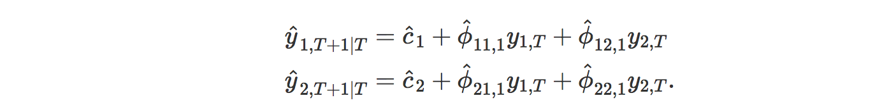

except that the errors have been set to zero and parameters have been replaced with their estimates. For h=2, the forecasts are given by

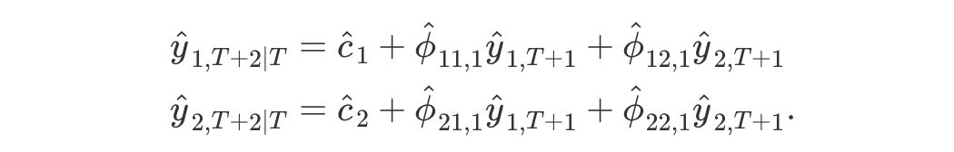

Again, this is the same form as [(1.1)](https://otexts.org/fpp2/VAR.html#eq:var1a)–[(1.2)](https://otexts.org/fpp2/VAR.html#eq:var1b), except that the errors have been set to zero, the parameters have been replaced with their estimates, and the unknown values of y1 and y2 have been replaced with their forecasts. The process can be iterated in this manner for all future time periods.

There are two decisions one has to make when using a VAR to forecast, namely how many variables (denoted by K) and how many lags (denoted by p) should be included in the system. The number of coefficients to be estimated in a VAR is equal to K+pK2 (or 1+pK per equation). For example, for a VAR with K=5 variables and p=3 lags, there are 16 coefficients per equation, giving a total of 80 coefficients to be estimated. The more coefficients that need to be estimated, the larger the estimation error entering the forecast.

In practice, it is usual to keep K small and include only variables that are correlated with each other, and therefore useful in forecasting each other. Information criteria are commonly used to select the number of lags to be included.

Vector autoregressions (VARs) constitute a special case of the more general class of VARMA models. In essence, a VAR model is a fairly unrestricted (flexible) approximation to the reduced form of a wide variety of dynamic econometric models. VAR models can be specified in a number of ways. Funke (1990) presented five different VAR specifications and compared their forecasting performance using monthly industrial production series. Dhrymes and Thomakos (1998) discussed issues regarding the identification of structural VARs. Hafer and Sheehan (1989) showed the effect on VAR forecasts of changes in the model structure. Explicit expressions for VAR forecasts in levels are provided by Arin˜o and Franses (2000); see also Wieringa and Horva´th (2005). Hansson, Jansson, and Lo¨ f (2005) used a dynamic factor model as a starting point to obtain forecasts from parsimoniously parametrized VARs. In general, VAR models tend to suffer from doverfittingT with too many free insignificant parameters. As a result, these models can provide poor outof-sample forecasts, even though within-sample fitting is good; see, e.g., Liu, Gerlow, and Irwin (1994) and Simkins (1995). Instead of restricting some of the parameters in the usual way, Litterman (1986) and others imposed a prior distribution on the parameters, expressing the belief that many economic variables behave like a random walk. BVAR models have been chiefly used for macroeconomic forecasting (Artis & Zhang, 1990; Ashley, 1988; Holden & Broomhead, 1990; Kunst & Neusser, 1986), for forecasting market shares (Ribeiro Ramos, 2003), for labor market forecasting (LeSage & Magura, 1991), for business forecasting (Spencer, 1993), or for local economic forecasting (LeSage, 1989). Kling and Bessler (1985) compared out-of-sample forecasts of several thenknown multivariate time series methods, including Litterman’s BVAR model. The Engle and Granger (1987) concept of cointegration has raised various interesting questions regarding the forecasting ability of error correction models (ECMs) over unrestricted VARs and BVARs. Shoesmith (1992), Shoesmith (1995), Tegene and Kuchler (1994), and Wang and Bessler (2004) provided empirical evidence to suggest that ECMs outperform VARs in levels, particularly over longer J.G. De Gooijer, R.J. Hyndman / International Journal of Forecasting 22 (2006) 443–473 449 forecast horizons. Shoesmith (1995), and later Villani (2001), also showed how Litterman’s (1986) Bayesian approach can improve forecasting with cointegrated VARs. Reimers (1997) studied the forecasting performance of seasonally cointegrated vector time series processes using an ECM in fourth differences. Poskitt (2003) discussed the specification of cointegrated VARMA systems. Chevillon and Hendry (2005) analyzed the relationship between direct multi-step estimation of stationary and nonstationary VARs and forecast accuracy.

Artificial Intelligence

Describe, define, uses, maths, current work, your view

#### Machine Learning

Describe, define, uses, maths, current work, your view

### Neural Network

Describe, define, uses, maths, current work, your view

#### CNN

Describe, define, uses, maths, current work, your view

#### RNN

Describe, define, uses, maths, current work, your view

Go into detail maths

#### GRU

Describe, define, uses, maths, current work, your view

#### Attention based networks

Describe, define, uses, maths, current work, your view

#### LSTM

Describe, define, uses, maths, current work, your view

Go into detail

Extra maths

Vanishing gradient / exploding gradient maths

Gradient descent maths

Regularisers maths

Weights and biases maths

#### Inference from review

#### Inference from research

Artificial Neural Networks

What is a neural network? To get started, I'll explain a type of artificial neuron called a *perceptron*. Perceptrons were [developed](http://books.google.ca/books/about/Principles_of_neurodynamics.html?id=7FhRAAAAMAAJ) in the 1950s and 1960s by the scientist [Frank Rosenblatt](http://en.wikipedia.org/wiki/Frank_Rosenblatt), inspired by earlier [work](http://scholar.google.ca/scholar?cluster=4035975255085082870) by [Warren McCulloch](http://en.wikipedia.org/wiki/Warren_McCulloch) and [Walter Pitts](http://en.wikipedia.org/wiki/Walter_Pitts). Today, it's more common to use other models of artificial neurons - in this book, and in much modern work on neural networks, the main neuron model used is one called the *sigmoid neuron*. We'll get to sigmoid neurons shortly. But to understand why sigmoid neurons are defined the way they are, it's worth taking the time to first understand perceptrons.

So how do perceptrons work? A perceptron takes several binary inputs, x1,x2,…x1,x2,…, and produces a single binary output:

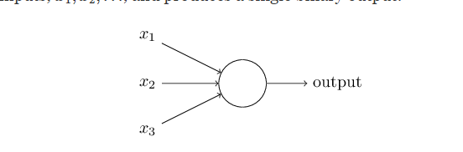

Recurrent Neural Network

In the next section I'll introduce a neural network that can do a pretty good job classifying handwritten digits. In preparation for that, it helps to explain some terminology that lets us name different parts of a network. Suppose we have the network:

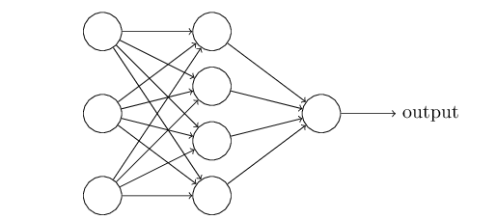

As mentioned earlier, the leftmost layer in this network is called the input layer, and the neurons within the layer are called input neurons. The rightmost or output layer contains the output neurons, or, as in this case, a single output neuron. The middle layer is called a hidden layer, since the neurons in this layer are neither inputs nor outputs. The term "hidden" perhaps sounds a little mysterious - the first time I heard the term I thought it must have some deep philosophical or mathematical significance - but it really means nothing more than "not an input or an output". The network above has just a single hidden layer, but some networks have multiple hidden layers. For example, the following four-layer network has two hidden layers:

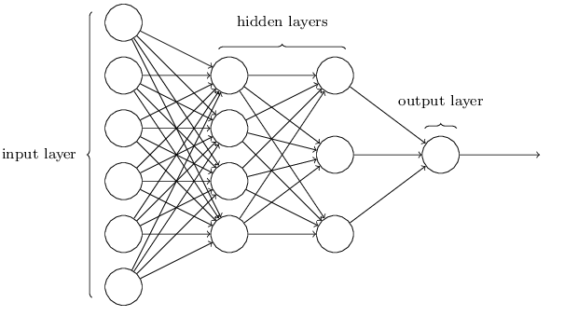

Somewhat confusingly, and for historical reasons, such multiple layer networks are sometimes called *multilayer perceptrons* or*MLPs*, despite being made up of sigmoid neurons, not perceptrons. I'm not going to use the MLP terminology in this book, since I think it's confusing, but wanted to warn you of its existence.

The design of the input and output layers in a network is often straightforward. For example, suppose we're trying to determine whether a handwritten image depicts a "9" or not. A natural way to design the network is to encode the intensities of the image pixels into the input neurons. If the image is a 6464 by 6464 greyscale image, then we'd have 4,096=64×644,096=64×64 input neurons, with the intensities scaled appropriately between 00 and 11. The output layer will contain just a single neuron, with output values of less than 0.50.5 indicating "input image is not a 9", and values greater than 0.50.5 indicating "input image is a 9 ".

While the design of the input and output layers of a neural network is often straightforward, there can be quite an art to the design of the hidden layers. In particular, it's not possible to sum up the design process for the hidden layers with a few simple rules of thumb. Instead, neural networks researchers have developed many design heuristics for the hidden layers, which help people get the behaviour they want out of their nets. For example, such heuristics can be used to help determine how to trade off the number of hidden layers against the time required to train the network. We'll meet several such design heuristics later in this book.

Up to now, we've been discussing neural networks where the output from one layer is used as input to the next layer. Such networks are called *feedforward* neural networks. This means there are no loops in the network - information is always fed forward, never fed back. If we did have loops, we'd end up with situations where the input to the σσ function depended on the output. That'd be hard to make sense of, and so we don't allow such loops.

However, there are other models of artificial neural networks in which feedback loops are possible. These models are called[recurrent neural networks](http://en.wikipedia.org/wiki/Recurrent_neural_network). The idea in these models is to have neurons which fire for some limited duration of time, before becoming quiescent. That firing can stimulate other neurons, which may fire a little while later, also for a limited duration. That causes still more neurons to fire, and so over time we get a cascade of neurons firing. Loops don't cause problems in such a model, since a neuron's output only affects its input at some later time, not instantaneously.

Recurrent neural nets have been less influential than feedforward networks, in part because the learning algorithms for recurrent nets are (at least to date) less powerful. But recurrent networks are still extremely interesting. They're much closer in spirit to how our brains work than feedforward networks. And it's possible that recurrent networks can solve important problems which can only be solved with great difficulty by feedforward networks. However, to limit our scope, in this book we're going to concentrate on the more widely-used feedforward networks.

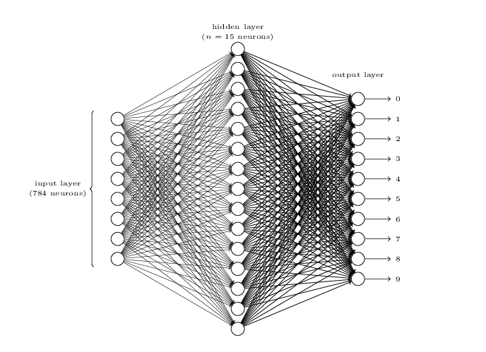

The input layer of the network contains neurons encoding the values of the input pixels. As discussed in the next section, our training data for the network will consist of many 2828 by 2828 pixel images of scanned handwritten digits, and so the input layer contains 784=28×28784=28×28 neurons. For simplicity I've omitted most of the 784784 input neurons in the diagram above. The input pixels are greyscale, with a value of 0.00.0 representing white, a value of 1.01.0representing black, and in between values representing gradually darkening shades of grey.

The second layer of the network is a hidden layer. We denote the number of neurons in this hidden layer by nn, and we'll experiment with different values for nn. The example shown illustrates a small hidden layer, containing just n=15n=15 neurons.

The output layer of the network contains 10 neurons. If the first neuron fires, i.e., has an output ≈1≈1, then that will indicate that the network thinks the digit is a 00. If the second neuron fires then that will indicate that the network thinks the digit is a 11. And so on. A little more precisely, we number the output neurons from 00 through 99, and figure out which neuron has the highest activation value. If that neuron is, say, neuron number 66, then our network will guess that the input digit was a 66. And so on for the other output neurons.

You might wonder why we use 1010 output neurons. After all, the goal of the network is to tell us which digit (0,1,2,…,90,1,2,…,9) corresponds to the input image. A seemingly natural way of doing that is to use just 44 output neurons, treating each neuron as taking on a binary value, depending on whether the neuron's output is closer to 00 or to 11. Four neurons are enough to encode the answer, since 24=1624=16 is more than the 10 possible values for the input digit. Why should our network use 1010 neurons instead? Isn't that inefficient? The ultimate justification is empirical: we can try out both network designs, and it turns out that, for this particular problem, the network with 1010output neurons learns to recognize digits better than the network with 44 output neurons. But that leaves us wondering *why* using 1010output neurons works better. Is there some heuristic that would tell us in advance that we should use the 1010-output encoding instead of the 44-output encoding?

To understand why we do this, it helps to think about what the neural network is doing from first principles. Consider first the case where we use 1010 output neurons. Let's concentrate on the first output neuron, the one that's trying to decide whether or not the digit is a 00. It does this by weighing up evidence from the hidden layer of neurons. What are those hidden neurons doing? Well, just suppose for the sake of argument that the first neuron in the hidden

**Backpropagation through Time**

The recurrent structure makes traditional backpropagation infeasible because of that with the recurrent structure, there is not an end point where the backpropagation can stop. Intuitively, one solution is to unfold the recurrent structure and expand it as a feedforward neural network with certain time steps and then apply traditional backpropagation

onto this unfolded neural network. This solution is known as Backpropagation through Time

(BPTT), independently invented by several researchers including (Robinson and Fallside,1987; Werbos, 1988; Mozer, 1989)

However, as recurrent neural network usually has a more complex cost surface, naïve backpropagation may not work well. Later in this paper, we will see that the recurrent structure introduces some critical problems, for example, the vanishing gradient problem, which makes optimization for RNN a great challenge in the society.

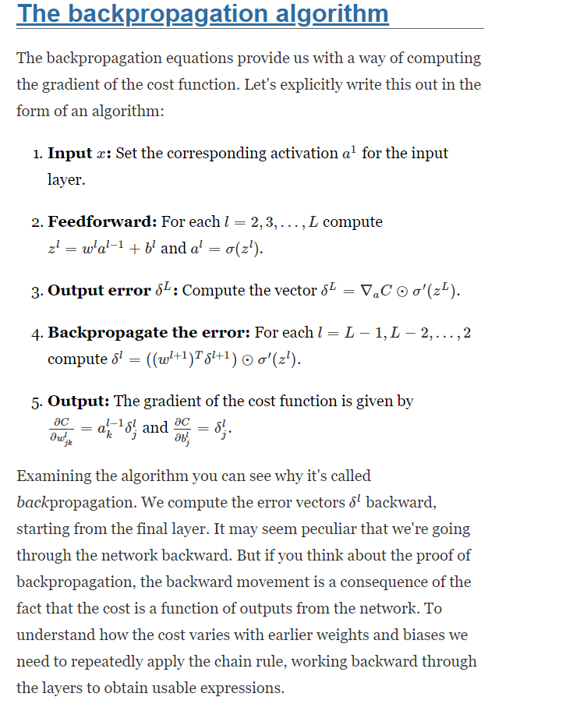

**Vanishing Gradient**

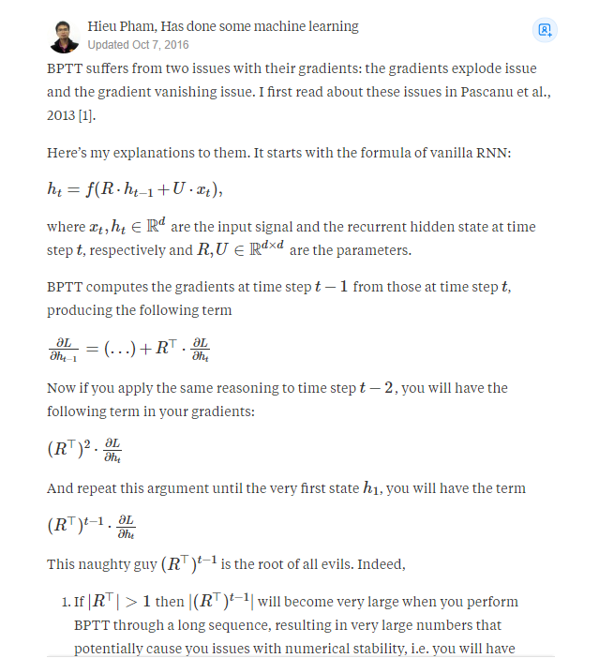

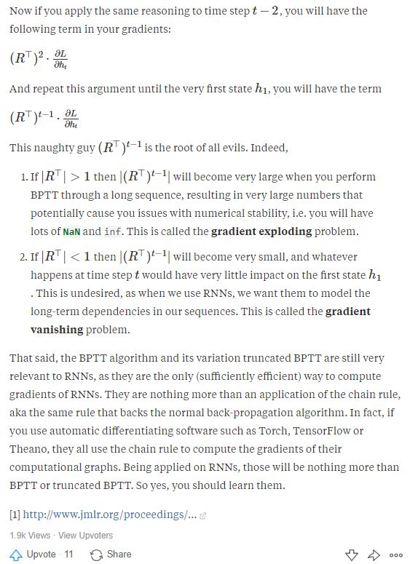

**LSTM**

Another breakthrough in RNN family was introduced in the same year as BRNN. Hochreiter and Schmidhuber (1997) introduced a new neuron for RNN family, named Long Short-Term Memory (LSTM). When it was invented, the term “LSTM” is used to refer the algorithm that is designed to overcome vanishing gradient problem, with the help of a special designed

memory cell

LSTM is widely used to denote any recurrent network that

with that memory cell, which is nowadays referred as an LSTM cell.

LSTM was introduced to overcome the problem that RNNs cannot long term dependencies (Bengio et al., 1994). To overcome this issue, it requires the specially designed memory cell, as illustrated in Figure 24 (a).

LSTM consists of several critical components

Distinction between Markov Chains and RNN

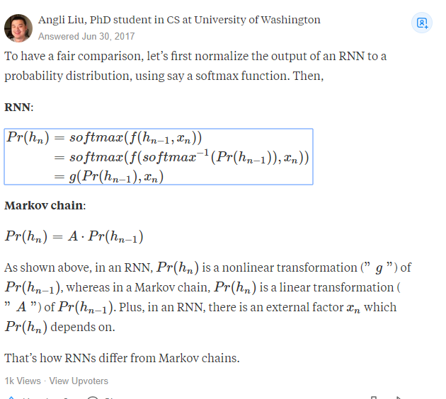

I suspect this is because fittedvalues are predictions of the differenced series. If you want predictions in terms of the original series, you can do:

**Adam Optimizer**

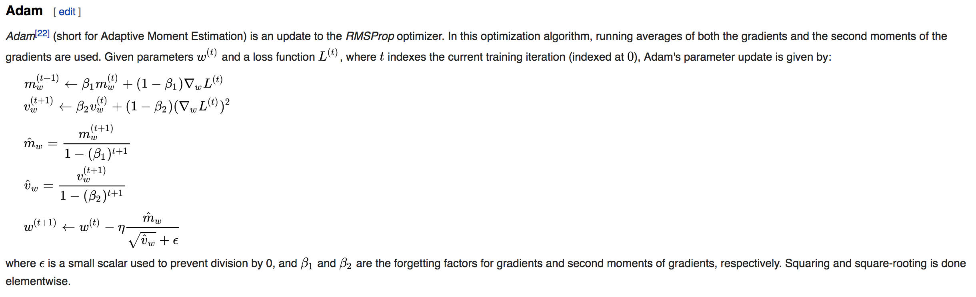

fittedvalues = res.predict(typ='levels')



Batch size determination

too small and you risk making your learning too stochastic, faster but will converge to unreliable models, too big and it wont fit into memory and still take ages.

In the neural network terminology:

* one **epoch** = one forward pass and one backward pass of *all* the training examples
* **batch size** = the number of training examples in one forward/backward pass. The higher the batch size, the more memory space you'll need.
* number of **iterations** = number of passes, each pass using [batch size] number of examples. To be clear, one pass = one forward pass + one backward pass (we do not count the forward pass and backward pass as two different passes).

Example: if you have 1000 training examples, and your batch size is 500, then it will take 2 iterations to complete 1 epoch.

When **solving** with a CPU an **Optimization Problem**, you **Iteratively apply** an **Algorithm** **over** some Input **Data**. In each of these iterations you usually update a Metric of your problem **doing** some **Calculations** **on** the **Data**. Now **when** the size of your **data** is **large** it might **need** a **considerable** amount of **time** to complete every iteration, **and** may consume a lot of **resources**. **So** sometimes you choose to **apply** these iterative **calculations** **on** a **Portion** **of** the **Data** to save time and computational resources. This portion is the batch_size and the process is called (in the Neural Network Lingo) batch data processing. When you apply your computations on all your data, then you do online data processing. I guess the terminology comes from the 60s, and even before. Does anyone remember the .bat DOS files? But of course the concept incarnated to mean a thread or portion of the data to be used.

Glossary

**Batch size** is a term used in machine learning and refers to the number of training examples utilised in one iteration. The **batch size** can be one of three options: **batch** mode: where the **batch size** is equal to the total dataset thus making the iteration and **epoch** values equivalent.

### Summary

## Chapter IV. Classical Methods

In this section a limited analysis of two classic linear predictor is presented. The commodity selected for analysis is **Gold**. The commodity was selected for the following reasons, historic and reliable price quotes for are monthly (not) is you wish to go back a long time historically Gold as an asset relative to other financial instrument is illiquid and relatively stable. In comparison to other asset Gold is not as volatile, thus not prone to arbitrary jumps. Forecasting gold prices with machine learning is one of the motivations for this paper. There is a common conception that deep learning algorithm perform poorly with small datasets. In this experiment the commodity Gold, with monthly dataset for over 30 years will be applied to various predictive models, the objective is to compare the relative performance of classic models, including VAR and ARIMA, then contrast the predictive performance with a machine learning algorithm LSTM.

### Exploratory Data Analysis

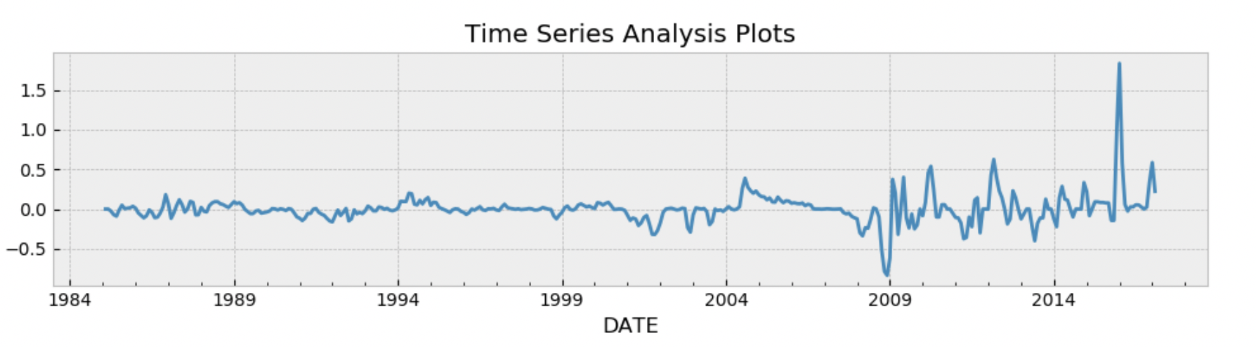

Autocorrelation

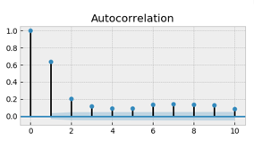

Partial Autocorrelation

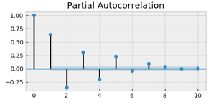

QQ Plot

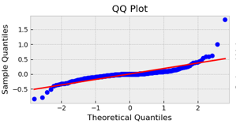

Probability Plot

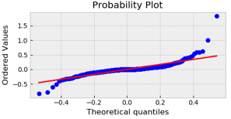

Descriptive Statistics

Distribution of returns

Test for stationarity

|  |  |
| --- | --- |
| Dicky fuller Test | Box-Ljung test |
|  |  |

VAR Model

Model Summary

|  |  |  |  |
| --- | --- | --- | --- |
| Model: | VAR |  |  |
| Method: | OLS |  |  |
| No. of Equations: | 4 | BIC: | -27.3445 |
| Nobs: | 381 | HQIC: | -27.7690 |
| Log likelihood: | 3248.71 | FPE: | 6.59078e-13 |
| AIC: | -28.0482 | Det(Omega_mle): | 5.53483e-13 |

|  |  |  |  |  |
| --- | --- | --- | --- | --- |
|  | coefficient | std. error | t-stat | prob |
| const | 0.008636 | 0.004346 | 1.987 | 0.047 |
| L1.Gold_ret | 0.650066 | 0.051679 | 12.579 | 0.000 |
| L2.Gold_ret | -0.499789 | 0.059456 | -8.406 | 0.000 |
| L3.Gold_ret | 0.31606 | 0.059173 | 5.341 | 0.000 |
| L4.Gold_ret | -0.14064 | 0.051525 | -2.73 | 0.006 |

VAR Gold

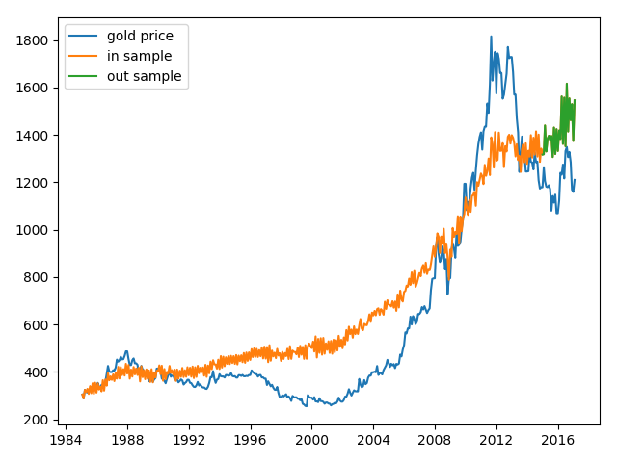

Residual plot

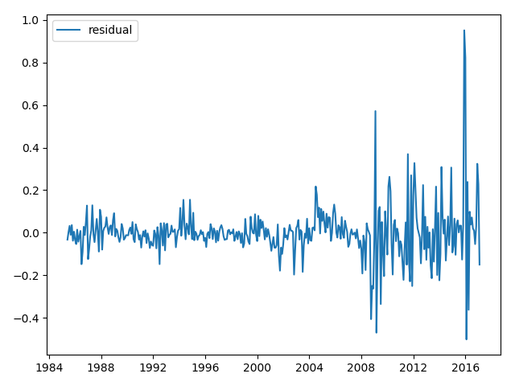

Error Metrics

rmse 238.01521006034054

mse 56651.24022006804

mse_log 0.03317009614943625

rsquared -6.330709837631952

mae 218.71415906552355

### Auto Regressive Integrated Moving Average

ARIMA Gold

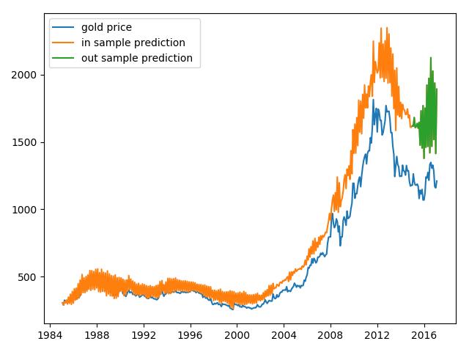

Residual plot

## Chapter IV. LSTM

### Mathematical Formulation

### Experiment

### Dataset Division

### Building The Model

### Training Model

### Validation Technique

### Tuning The Model

### Summary

## Chapter V. Comparative Analysis

### Experimental Data

The dataset used in the experiment describes the monthly prices for Gold over a 30-year period from 1985-02-01 to 2017-02-01. Gold was chosen for it relative stability with respect to price, Gold was selected instead of monthly interest rate because although gold price is generally stable, it can become volatile when markets become uncertain and as business cycle changes. There are 386 observations in the dataset. The original dataset is credited to yahoo finance.

### Training and Validation Dataset

The two key tasks regarding data splitting were

1. with fewer training sets, parameter estimates variance will be high.
2. With fewer testing sets, performance statistic variance will be high.

The dataset was divided such that both concerns were addressed. In spite of the limited dataset, the model can be computationally expensive, using a limited dataset was a deliberate design decision for this experiment. Training Data was 80 percent, Testing Data, 20 percent Validation Data, 20 percent of Training Data.

|  |  |
| --- | --- |
| **Data** | **Count** |
| Training | 310 |
| Testing | 76 |
| Validation | 62 |

Several runs were executed with different amounts of training data, e.g randomly sample 25 percent of the training data a few times to observe performance on the validation data, again we repeat with 30 and 50 percent, to observe lower variance across the .You should see both greater performance with more data, but also lower variance across the various samples.

Data Transformation

The dataset was transformed to ensure the data is stationary, one of the ways to achieve this is by differencing the data to remove properties such as trends and seasonality. To complete the forecasting process, the data will be inverted restore the data back into its original scale. Python provides handy function to achieve differencing. Input data into the neural network will have be scaled to fit into the activation function of LSTM, the function output is within the range (-1,1). Th scaling coefficient values is calculated on the training set and applied to the test set. The dataset “array” is reshaped into a matrix before scaling the data to range between (-1,1)

### Building the model

The model was implemented using industry standard deep learning python packages

Kera, Tensorflow. The solution was developed on mac book pro without GPU. One of the key contributions of LSTM architecture is its capacity to remain stateful and maintain memory over long sequences, without reliance on lagged observation as input. The Kera package exposes several high level api that gives us fine grained access to the model’s properties.

Before we build the model, we need to simplify and reframe the problem into a supervised learning problem. We can achieve this by feeding in observation from previous time step as input into the current time step. The data is modified such that we push all values in a series down by a specific number of place e.g 1. The sifted data will become the input variable and the original time series then become the output variable.

We frame the problem as each time step in the original sequence is one separate sample, with one timestep and one feature. Below is high level pseudocode

1. We specify the shape of the input layer, using the *batch_input_shape* parameter

This parameter specifies the number of

* Batch size
* Time step
* Feature

1. neuron is specified in the output layer with an activation function
2. Loss function: “mean squared error”
3. Specify optimiser: “Adam”
4. Compile the model
5. Fit model to training data

Note there are lots of options provided by the Kera library that were used while experimenting

#### Running the Forecast

We update the model each time step of the test data as new observations from the test data are made available (the dynamic approach). The *predict* function returns an array of predictions, one for each input row provided. Because we are providing a single input, the output will be a 2 dimensional array with one value. Given a fit model, a batch-size used when fitting the model (e.g. 1), and a row from the test data, the function will separate out the input data from the test row, reshape it, and return the prediction as a single floating point value. We would like the model to build up state as we forecast each time step in the test dataset. We seed the state by making a prediction on all samples in the training dataset. the internal state should be set up ready to forecast the next time step.

Evaluating the model

1. Evaluate forecast, print root mean squared error
2. Print forecast and diagnostic graphs

Rsquared and

T test statistc

LSTM accuracy score

Dropout 0.1 Epoch 400 Batch size = 4

RMSE for all 3 models to compare

From were able to achieve good result as

|  |
| --- |
| **LSTM Result** |
|  |

|  |
| --- |
| **LSTM Result** |
|  |

Comparison of RMSE across three models

#### Epoch size

The RMSE for train dataset in blue and test dataset in orange. The performance of the model increases as the average error rate decreases with the gradual increment in epoch sizes up until around 370 epoch. The charts below were generated by training the model at least 30 times to capture the average rate.

|  |  |
| --- | --- |
| **epoch = 50** | **epoch = 100** |
|  |  |
| **epoch = 200** | **epoch = 400** |
|  |  |
| **epoch = 500** | **epoch = 600** |
|  |  |

RMSE Summary statistic for multiple epochs

|  |  |  |  |  |  |
| --- | --- | --- | --- | --- | --- |
| **epoch** | **50** | **100** | **200** | **400** | **600** |
| count | 30 | 30 | 30 | 30 | 30 |
| mean | 0.041167 | 0.038932 | 0.039237 | 0.039051 | 0.039483 |
| std | 0.002293 | 0.002645 | 0.002693 | 0.002132 | 0.001907 |
| min | 0.037459 | 0.035155 | 0.034444 | 0.035461 | 0.03608 |
| 25% | 0.040149 | 0.036894 | 0.036413 | 0.037103 | 0.038752 |
| 50% | 0.040642 | 0.038702 | 0.039712 | 0.039171 | 0.039282 |
| 75% | 0.04192 | 0.041404 | 0.041226 | 0.039775 | 0.04015 |
| max | 0.04738 | 0.043446 | 0.0438 | 0.043938 | 0.044287 |

Distributions shown on a box and whisker plot, helps us to visually compare errors somewhat objectively the distributions directly compare. The green line shows the median and the box shows the 25th and 75th percentiles, or the middle 50% of the data. This comparison also shows that setting epochs round about the 400 mark, it has the second lowest average performance but also the fewest lower percentile error. It took nearly 8 hours on a quad core 2017 mac book pro, 16G of ram, but no GPU to get a single run for the box plot below.

Box and whisker plot for multiple epochs

|  |
| --- |
| **Box Plot Multiple Epochs** |
|  |

#### Model training Vs Validation Loss

The charts below illustrates the model converging nicely at around 300 epochs and starts to overfit slightly at around 370 epoch. These validation loss graphs are provide by the Kera’s library. The plot is model training loss against the model’s validation loss.

|  |
| --- |
| **epoch = 200** |
|  |
|  |
| **epoch = 200** |
|  |
|  |
| **epoch = 300** |
|  |
|  |
| **epoch = 400** |
|  |

#### Batch size

The results from tuning the batch size was surprising, conventional knowledge is the bigger the batch size the better the model gets trained. Note the size of the data in the experiment was limited by design. Batch number = 2 seems to offer the best performance, once again notice where batch =2 the inflection point at around 370 epoch the instability is reflected in both the train and test RMSE.

|  |  |  |
| --- | --- | --- |
| **epoch = 600, batch = 1** | **epoch = 600, batch = 2** | **epoch = 600, batch = 4** |
|  |  |  |

#### Number of neurons

|  |  |  |
| --- | --- | --- |
| **epoch = 600, neuron = 1** | **epoch = 600, neuron = 2** | **epoch = 600, neuron = 3** |
|  |  |  |

There appears to be clear performance gain from increasing the number of neurons to two the average of the error rate decreases markedly with 2 neurons.

RMSE Summary statistic for multiple neuron

|  |  |  |  |  |
| --- | --- | --- | --- | --- |
| **neuron** | **1** | **2** | **3** | **4** |
| count | 10 | 10 | 10 | 10 |
| mean | 0.038439 | 0.039395 | 0.039196 | 0.040182 |
| std | 0.001838 | 0.001855 | 0.001599 | 0.001527 |
| min | 0.035673 | 0.036152 | 0.03713 | 0.037353 |
| 25% | 0.036902 | 0.038298 | 0.037716 | 0.039769 |
| 50% | 0.039125 | 0.039594 | 0.039698 | 0.040146 |
| 75% | 0.039521 | 0.040842 | 0.040349 | 0.041369 |
| max | 0.040451 | 0.04181 | 0.041721 | 0.042362 |

Box and whisker plot for various neuron sizes

|  |
| --- |
| **Box Plot Multiple Neurons** |
|  |

### Pertubing the Model

Mathematical formulation of LSTM,

|  |  |  |
| --- | --- | --- |
|  | $$i_{t}=σ\left(W^{i}x_{t}+U^{i}{h_{t}}_{-1}\right)$$ | (1) |

|  |  |  |
| --- | --- | --- |
|  |  | (2) |

|  |  |  |
| --- | --- | --- |
|  |  | (3) |

|  |  |  |
| --- | --- | --- |
|  |  | (4) |

|  |  |  |
| --- | --- | --- |
|  |  | (5) |

|  |  |  |
| --- | --- | --- |
|  |  | (6) |

$\left[W^{i}, W^{f}, W^{o}, U^{i}, U^{f}, U^{o}\right]$ are weight matrices,

$x_{t}$ is the vector input at time step $t,$

$h_{t}$ is the hidden state, $c_{t}$ is the memory cell state

$⊙$ is the element by element multiplication

$σ$ is the sigmoid function

Optimisation

Stochastic gradient descent is a popular training method, the problem can be framed as non convex optimisation problem

|  |  |  |
| --- | --- | --- |
|  | $$\min_{w}{=\sum_{i=1}^{N}{f_{i}\left(w\right),}}$$ | (7) |

Where $f_{i}$ is the loss function for the $i^{th}$ data point,

$w$ are the weights of the network, Given a sequence of learning rate $γ_{κ},$

SGD takes the form

|  |  |  |
| --- | --- | --- |
|  | $${w_{κ}}_{+1}=w_{κ}-γ_{κ}\hat{∇}f(w_{k})$$ | (8) |

### Summary

## Conclusion.

### Concluding Remarks

The advancement in machine learning techniques and deep learning algorithms has made deep learning area a keenly researched discipline. The question of accuracy and stability of Machine learning model has drawn so much interest and thus the quest here was to explore a segment of time series forecasting with machine learning. Models may be inspired by domain knowledge outside of engineering or statistics, e.g the human visual cortex is said to have inspired the development of convolutional neural networks.

This paper primarily focuses on LSM's model performance mainly, but also compares the accuracy of ARIMA and VAR to LSTM, as representative techniques when forecasting monthly time series for Gold. These two techniques were implemented and applied on a set of financial data for Gold. In this paper. Three major family of forecasting models were reviewed, implemented and analysed. Auto Regressive Integrated Moving Average, Vector Auto Regression and Recurrent Neural Network composed of Long Short Term Memory unit. The research question this paper set out to answer was to identify the efficacy and accuracy of predictions LSTM architecture in predicting commodity prices, with limited dataset and to verify if LSTM model outperform ARIMA or VAR.

### Key Points

The findings and conclusion of this experiment is consistent with the hypothesis that deep learning neural network architecture, with limited datasets, can produce robust and better fitting models than ARIMA and VAR. It is also clear that deep learning models LSTM when tuned correctly can perform and converge faster than ARIMA and VAR, the speed of convergence was not documented as part of this experiment but observed while running the experiment. By Increasing the number of neurons and epoch the LSTM model experienced clear performance improvement, These two hyper parameters are essential blocks for tuning the model.

By visually inspection of the graph and observing the RMSE, it is apparent that the LSTM-model seemed to have higher prediction accuracy than the VAR and ARIMA model. The VAR model perform comparably well at the beginning of out sample comparison (see VAR graph) Given that VAR and ARIMA are well established and mature models that are widely used in industry, the LSTM architecture results stands out, based on the limited subset of data used in this experiment

focus however was on the application of the Long Short Term Memory variant of recurrent neural network. Deep learning models: the deep generative model family, convolutional neural network family, and recurrent neural network family as well as some topics for optimization techniques. A proposed model with significantly more parameters than contemporaneous ones must solve problems that no others can solve unambiguously to be noteworthy.

### Recommendations for Future Research

#### Dropout, Optimization Algorithm, Loss Function.

Experiment and explore by trying out the following, apply other regularization methods e.g dropout on LSTM connections. Apply other optimization algorithms, experiment with [different loss functions](https://keras.io/objectives/), to tweak model performance. Test training speed by using lag observations as input features and input time steps of the feature to see if they improve learning and/or forecasting performance of the model.

#### LSTM in deep reinforcement learning for time series prediction

An area of recent interest in research is reinforcement learning. LSTM is a way in which an agent can build a model of hidden or unobserved state in order to enhance its predictiveness, when information from direct observation do not suffice, but a history of observations may be more reliable. Applying LSTM in a Reinforcement learning environment will be challenging. LSTM requires input of multiple related time steps at once, not randomly sampled individual time steps. Some LSTM architecture might yield better result, if histories of longer trajectories are preserved and long trajectories or even complete episodes are sampled.

## [References]

Last Name, Full First Name. *Basic MLA Style Only*. City: Publisher, Year. Print.

Last Name, First and Middle Initials (Year). *Basic APA Style Only.* City, State Abbreviation: Publisher.

Last Name, First Name. *Basic CMS Style Only, Requires Footnotes or Endnotes.* Place of publication: Publisher, Year.

### Bibliography

Al-Radaideh, Q., Abu Assaf, A. & Alnagi, E., 2013. *Predicting Stock Prices Using Data Mining Techniques.* s.l.:s.n.

Baker, S. A. & van Tassel, R. C., 1985. Forecasting the price of gold: A fundamentalist approach. *Atlantic Economic Journal,* 13(4), pp. 43-51.

Deng, L. & Yu, D., 2014. Deep Learning: Methods and Applications. *Foundations and Trends in Signal Processing,* , 7(3–4), p. .

Heaton, J. B., Polson, N. G. & Witte, J. H., 2016. Deep Learning for Finance: Deep Portfolios. *Applied Stochastic Models in Business and Industry,* , 33(1), pp. 3-12.

Pyo, S., Lee, J., Cha, M. & Jang, H., 2017. Predictability of machine learning techniques to forecast the trends of market index prices: Hypothesis testing for the Korean stock markets. *PLOS ONE,* 1, Volume 12, p. e0188107.

Glossary

**Samples**: These are independent observations from the dataset.

**Time steps**: These are individual time steps for a variable for a given observation period.

**Features**: Individual measures identified at the time of observation